**Cerner SurgiNet to Soarian Scheduling**

**SIU Requirements**

**Version 1.2**

**Prepared By: Sarah Thies & Art Schwartz**

**Date: 3/1/2017**

Document Control 3

Resources 3

Project Distribution List 3

Document Version Control 3

1. Introduction 4

1.1 Purpose 4

1.2 Project Scope 4

1.3 Terminology Standards 4

1.3.1 Acronyms 4

1.3.2 Glossary 4

1.4 Document References 4

1.5 configuration Files 4

*2.* Diagram 5

3.1 Functional Requirements (Cerner FSI) 6

3.2 Non-Functional Requirements 6

3.3 Messaging Protocols 6

3.3.1 Inbound to the BayCare Cloverleaf 7

3.3.2 Outbound to the BayCare Cloverleaf 7

3.3.3 Inbound to the Vendor 7

3.3.4 Outbound to the Vendor 7

3.3.5 Outbound to Soarian 7

3.3.6 Outbound BayCare Cerner to Cloverleaf 7

4. HL7 Messaging 7

4.1 Messaging Format 7

4.1.1 Segments 8

4.1*.*2 Messaging Event Types 8

4.1*.*3 Cloverleaf Configuration Files 8

4.1.4 Cloverleaf Site Location 9

4.2 Data Transformation Requirements 9

4.3 Sample Messages 12

5. Testing 14

5.1. Unit Testing Scenarios 14

5.2 Integrated Testing Scenarios 14

5.3 Testing Approvals 14

5.4 Piloting 14

5.5 Approvals 15

6. Deployment / Implementation Model 15

Appendix A: Risks and Concerns 15

Appendix B: Issues List 15

# **Document Control**

## Resources

|  |  |  |
| --- | --- | --- |
| **Name** | **Role** | **Email** |
| Sarah Thies | BayCare Integration Analyst | Sarah.Thies@baycare.org |
| Art Schwartz | BayCare Integration Analyst | Art.Schwartz@baycare.org |
| Cindy Barone | Supervisor Clinical Systems | Cynthia.Barone@baycare.org |
| Marybeth Langel | BayCare Sr. System Analyst | Marybeth.Langel@baycare.org |
| Larry Ruben | Siemens Principal Consultant, Enterprise Integration & Interoperability Solutions | [larry.ruben@cerner.com](mailto:larry.ruben@cerner.com) |
|  |  |  |
|  |  |  |
|  |  |  |

## Project Distribution List

## Document Version Control

|  |  |  |  |
| --- | --- | --- | --- |
| **Version** | **Date** | **Modifier** | **Description** |
| V1.0 | 3/2/2015 | Sarah Thies | Originally Created |
| V1.1 | 5/10/2016 | Sarah Thies | Added Bartow Acronym BRM |
| V1.2 | 3/1/17 | Art Schwartz | Updated Cloverleaf info |
|  |  |  |  |

# 1. Introduction

## 1.1 Purpose

This document outlines the changes required to accommodate SIU messages from Cerner Surginet to Soarian Scheduling. All gaps will be identified and mitigated as well as any non-functional requirements needed to support the solution post implementation.

## 1.2 Project Scope

We will interface scheduling messages from the Cerner Surginet application to the Soarian Scheduling application.

## 1.3 Terminology Standards

### 1.3.1 Acronyms

MLLP – Minimum Lower Layer Protocol for messaging framing a HL7 message.

### 1.3.2 Glossary

List the terms that require definition

## 1.4 Document References

**Cerner Specifications:**

Cerner_Unit_16o_-_Scheduling_Notifications_Outbound.pdf

## 1.5 configuration Files

**Cloverleaf translation:**

Cerner_soars_siu

**Cloverleaf tables:**

cer_soars_fac.tbl

SIU_message_types.tbl

# *2.* Diagram

Scheduling messages outbound Cerner to Soarian3. Requirements

## 3.1 Functional Requirements (Cerner FSI)

Provide detail for the below functional requirements. The message transformation requirements for the components defined in this specification should be specified in section 4.2 of this document.

|  |  |  |
| --- | --- | --- |
| **Cerner** |  |  |
| **Number** | **Requirement Name** | **Requirement Description** |
| FR.2015.1.0 | Corporate Patient Identifier (CPI )value | The CPI value is a unique number identifying the patient among all BayCare systems. |
| FR.2015.2.0 | AIS-3.1 | Soarian Scheduling requires the value ORSURGERY so it’s hard coded in Cerner. |
| FR.2015.3.0 | AIS-3.2 | Soarian Scheduling requires the value SURGERY so it’s hard coded in Cerner. |
| FR.2015.4.0 | MSH-4 | The facility acronym is scripted here for Cloverleaf to pass the associated Soarian value. |
| FR.2015.5.0 |  |  |
| FR.2015.6.0 | MSH-9 | Kill check-in messages |

## 3.2 Non-Functional Requirements

Provide concise detail for the below non-functional requirements. The below requirements must be evaluated for every project.

|  |  |  |
| --- | --- | --- |
| **Cerner** |  |  |
| **Number** | **Requirement Name** | **Requirement Description** |
| NFR.2015.1.0 | Click here to enter text. | Click here to enter text. |

## 3.3 Messaging Protocols

Below are listed the details for the messaging protocols that will be leveraged for this integration. Please see the reference document located on the Integration SharePoint server: <insert link to document here>

### 3.3.1 Inbound to the BayCare Cloverleaf

* TCPIP

### 3.3.2 Outbound to the BayCare Cloverleaf

* TCPIP

### 3.3.3 Inbound to the Vendor

TCPIP

### 3.3.4 Outbound to the Vendor

* TCPIP

### 3.3.5 Outbound to Soarian

Test

Port Number: 19204

IP Address: 64.46.197.19

Prod

Port Number: 19204

IP Address: Click here to enter text.

### 3.3.6 Outbound BayCare Cerner to Cloverleaf

**C30**

SIU_TCPIP_SURGINET_OUT

Port Number: 8184

IP Address: 10.100.128.66 (note that this is a ***Natted IP*** to Cloverleaf Test 10.5.250.203)

**P30**

SIU_TCPIP_SURGINET_OUT

Port Number: 21237

IP Address: 10.100.128.64(note that this is a ***Natted IP*** to Cloverleaf Prod 10.5.250.201)

# 4. HL7 Messaging

## 4.1 Messaging Format

### 4.1.1 Segments

The segments utilized for this interface are:

MSH

SCH - Schedule Activity Information

NTE

ZBX - Additional Appointment Information

PID

[PV1]

RGS - Required by HL7 to preserver message structure; Interface does ***not*** use

AIS - Appointment Information, Service

AIL - Appointment Information, Location Resource

AIP - Appointment Information, Personnel Resource

*Message Construction Notes:*

*[Square Brackets] – Optional*

*{Curly Brackets} – Repeatable*

*MSH – Message Header*

*EVN – Event segment*

*PID – Patient ID segment*

*PV1 – Patient Visit segment*

*ORC – Common Order segment*

*IN1 – Insurance segment*

*[{ – Start of optional, repeatable group*

*}] – End of optional, repeatable group*

### 4.1*.*2 Messaging Event Types

Below are the messages types necessary for this integration

|  |  |
| --- | --- |
| **Event Type** | **Description** |
| SIU^Book | S12 |
| SIU^Reschedule | S13 |
| SIU^Check In | S14 |
| SIU^Modify | S14 |
| SIU^Cancel | S15 |

### 4.1*.*3 Cloverleaf Configuration Files

For each HL7 interface specified in Section 2 of this document, identify the Cloverleaf Configuration Files: Variants, TCL Scripts, Xlates, etc.

### 4.1.4 Cloverleaf Site Location

**C30**

SITE: **cerner_emr** & THREAD: **crt_soars_in**

**P30**

SITE **cerner_emr_prod** & THREAD **cer_soars_in**

## 4.2 Data Transformation Requirements

In non-prod, ***ALL*** locations were aliased, sent outbound and tested.

In production ***ONLY*** SFB was done.  At Go Live, integration needed to script to IGNORE all the other locations.

We coded, in Cerner, for the following Surginet locations based on value from original production data (seen in column 1).

Move location value in AIL-3.4 to AIL-3.1 and update the value for Soarian *(if needed)*

Set Soarian generic value for AIP-3 based on Soarian location value in AIL-3.1

Move location value in AIL-3.4 to MSH-4 for Cloverleaf to map Soarian Facility IDs

| **Surginet Location (AIL-3.4)** | **Soarian Location (AIL-3.1)** | **Soarian Resource Code (AIP-3.1)** |
| --- | --- | --- |
| SFB | SFBH | SFORRM1 |
| MPH | MPH | MPORRM1 |
| SJH | SJH | JHORRM1 |
| SJW | SJWH | JWORRM1 |
| MDU | MDH | MDORRM1 |
| SAH | SAH | AHORRM1 |
| MCS | MCH | MCORRM1 |
| NBY | MPNBH | NBORRM1 |
| SJN | SJHN | JNORRM1 |
| WHH | WHH | WHORRM1 |
| WHW | WHW | WHWORRM1 |
| BRM | BRM | BRORRM1 |

| **Field Description** | **HL7 Field Loc.** | **Required Y/N** | **Data Type** | **Length** | **Notes** |
| --- | --- | --- | --- | --- | --- |
| MSH Segment | MSH |  |  |  | Path copy MSH Segment |
| Sending application | MSH-3 |  |  |  | Hard code =GENAPPT |
| Sending Facility | MSH-4 |  |  |  | Table - cer_soars_fac.tbl |
| Receiving application | MSH-5.1 |  |  |  | Hard code = =SOARIAN |
| Receiving application | MSH-5.2 |  |  |  | Hard code = =SCHEDULING |
| Receiving Facility | MSH-6 |  |  |  | Table - cer_soars_fac.tbl |
| Message Type | MSH-9 |  |  |  | Table - SIU_message_types.tbl |
| Placer appointment ID | SCH-1 |  |  |  | Copy |
| Filler appointment ID | SCH-2.1 |  |  |  | Copy from SCH-1.1 |
| Filler appointment ID | SCH-2.2 |  |  |  | Copy from SCH-1.2 |
| Appointment Reason | SCH-7 |  |  |  | Copy |
| Appointment Duration | SCH-9 |  |  |  | Copy |
| Appointment Duration units | SCH-10 |  |  |  | Copy |
| Appointment Time Quantity | SCH-11 |  |  |  | Copy (remove seconds) |
| Placer Contact Person | SCH-12 |  |  |  | Copy |
| Entered by Person | SCH-20 |  |  |  | Copy |
| Set ID | PID-1 |  |  |  | Copy |
| Patient ID | PID-3 |  |  |  | 1st iteration Baycare CMRN  900000 in 4th subfield  PI in 5th  2ndt iteration Baycare CMRN  504 in 4th subfield  MR in 5th |
| Patient Name | PID-5 |  |  |  | Copy |
| DOB | PID-7 |  |  |  | Copy |
| Sex | PID-8 |  |  |  | Copy |
| Race | PID-10 |  |  |  | Copy |
| Address | PID-11 |  |  |  | Copy |
| Patient Account Number | PID-18 |  |  |  | Copy |
| Patient Class | PV1-2 |  |  |  | Copy |
| Set ID | AIS-1 |  |  |  | Copy |
| Universal service Number | AIS-3 |  |  |  | Copy |
| Start date | AIS-4 |  |  |  | Copy (trim Seconds) |
| Duration | AIS-7 |  |  |  | Copy |
| Duration units | AIS-8 |  |  |  | Copy |
| Location Resource | AIL-3 |  |  |  | Copy |
| Personnel Resource ID | AIP-3 |  |  |  | Copy |

## 4.3 Sample Messages

**Cerner**

**Standard Outbound Cerner:**

MSH|^~\&|HNAM|SJH|SOARIAN|BAYCARE|20140327133111||SIU^Book|Q1780261808T1994759605||2.3

SCH|4283782.000^HNAMSCHEVID||||||Surgery^^^Surgery||30|ZZ|^^30^20140328092000^20140328095000|||||^Maqnxm^Yajwuxve^^^^^^^Personnel||||^Maqnxm^Yajwuxve^^^^^^^Personnel|||||Confirmed

NTE|1|Public Surgical Comments

NTE|2|Scheduling Guidelines|This patient has a documented Latex Allergy

ZBX|1||Activate order at check-in^Activate order at check-in||Y||||||||Processing Option

ZBX|2||Create surgical case^Create surgical case||Y||||||||Processing Option

ZBX|3||Dynamic durations^Dynamic durations||Y||||||||Processing Option

ZBX|4||Dynamic resources (preference cards)^Dynamic resources (preference cards)||Y||||||||Processing Option

ZBX|5||Force display of Appointment Attributes^Force display of Appointment Attributes||Y||||||||Processing Option

ZBX|6||Require encounter at booking^Require encounter at booking||Y||||||||Processing Option

ZBX|7||Require order association^Require order association||Y||||||||Processing Option

ZBX|8||Dynamic resources (order personnel)^Dynamic resources (order personnel)||Y||||||||Processing Option

ZBX|9||Preference cards - use appointment clean^Preference cards - use appointment clean||Y||||||||Processing Option

ZBX|10||Preference cards - use appointment durat^Preference cards - use appointment durat||Y||||||||Processing Option

ZBX|11||Preference cards - use appointment setup^Preference cards - use appointment setup||Y||||||||Processing Option

ZBX|12||Provider privilege checking^Provider privilege checking||Y||||||||Processing Option

ZBX|13|IS|Priority^Priority||Elective||||||||Event Detail

ZBX|14|ID|Surg Add On^Surg Add On||N||||||||Event Detail

ZBX|15|XCN|Primary Surgeon^Primary Surgeon||1373^Bailey^Christian^S^^^^^SJH Dr Number^Personnel^^^ORGANIZATION DOCTOR^CACTUS||||||||Event Detail

PID|1|337251^^^Saint Joseph's MRN^MRN^SJH|970220307^^^Mease Dunedin MRN^MRN^MDU~981378639^^^Morton Plant MRN^MRN^MPH~337251^^^Saint Joseph's MRN^MRN^SJH~102337851^^^BayCare CMRN^Community Medical Record Number^SJH|102337851^^^BayCare EAD CPI^Historical CMRN^SJH|SITRTWOSFB^SJHINSURGNINETE^E^^^^Current||19701024|F||Black|1701 14TH ST S^APT 3^SAINT PETERSBUR^FL^33705^^Home~9994 QFJPXJW JO^ATV99904^ZMXAJRAVXJ^FL^11548^^Home||(727)565-8041^Home1||EN|S|Baptist|38001021^^^Saint Joseph's FIN^FIN NBR^SJH|582104876|||Non HIS or LAT|||0

PV1|1|I|CD:662721^CD:306625701^CD:306625910^SJH^^Bed(s)^SJH|Urgent|||1373^Bailey^Christian^S^^^^^SJH Dr Number^Personnel^^^ORGANIZATION DOCTOR^CACTUS~1373^Bailey^Christian^S^^^^^SJW Dr Number^Personnel^^^ORGANIZATION DOCTOR^CACTUS~BB8580804^Bailey^Christian^S^^^^^DEA No^Personnel^^^DOCDEA^CACTUS~ME88869^Bailey^Christian^S^^^^^Doctor License Number^Personnel^^^LICENSENBR^CACTUS~OTH000^Bailey^Christian^S^^^^^UPIN^Personnel^^^DOCUPIN~1356321806^Bailey^Christian^S^^^^^NPI Number^Personnel^^^National Provider Identifier^CACTUS~D01373^Bailey^Christian^S^^^^^External Id^Personnel^^^External Identifier~78112^Bailey^Christian^S^^^^^MCS Dr Number^Personnel^^^ORGANIZATION DOCTOR^CACTUS~1373^Bailey^Christian^S^^^^^SJN Dr Number^Personnel^^^ORGANIZATION DOCTOR^CACTUS~D01373^Bailey^Christian^S^^^^^Username^Personnel^^^Username~78112^Bailey^Christian^S^^^^^SAH Dr Number^Personnel^^^ORGANIZATION DOCTOR^CACTUS~78112^Bailey^Christian^S^^^^^NBY Dr Number^Personnel^^^ORGANIZATION DOCTOR^CACTUS~78112^Bailey^Christian^S^^^^^SFB Dr Number^Personnel^^^ORGANIZATION DOCTOR^CACTUS~78112^Bailey^Christian^S^^^^^MPH Dr Number^Personnel^^^ORGANIZATION DOCTOR^CACTUS~78112^Bailey^Christian^S^^^^^MDU Dr Number^Personnel^^^ORGANIZATION DOCTOR^CACTUS~MS011948^Bailey^Christian^S^^^^^Username^Personnel^^^Username^CACTUS~MS011948^Bailey^Christian^S^^^^^BayCare DR Number^Personnel^^^ORGANIZATION DOCTOR||G98374^Fink^Andrew^J^^^^^UPIN^Personnel^^^DOCUPIN^CACTUS~11362^Fink^Andrew^J^^^^^MPH Dr Number^Personnel^^^ORGANIZATION DOCTOR^CACTUS~11362^Fink^Andrew^J^^^^^MCS Dr Number^Personnel^^^ORGANIZATION DOCTOR^CACTUS~11362^Fink^Andrew^J^^^^^MDU Dr Number^Personnel^^^ORGANIZATION DOCTOR^CACTUS~11362^Fink^Andrew^J^^^^^NBY Dr Number^Personnel^^^ORGANIZATION DOCTOR^CACTUS~84907^Fink^Andrew^J^^^^^SFB Dr Number^Personnel^^^ORGANIZATION DOCTOR^CACTUS~ME84907^Fink^Andrew^J^^^^^Doctor License Number^Personnel^^^LICENSENBR^CACTUS~1740232446^Fink^Andrew^J^^^^^NPI Number^Personnel^^^National Provider Identifier^CACTUS~BF6259697^Fink^Andrew^J^^^^^DEA No^Personnel^^^DOCDEA^CACTUS~2551^Fink^Andrew^J^^^^^SJH Dr Number^Personnel^^^ORGANIZATION DOCTOR^CACTUS~2551^Fink^Andrew^J^^^^^SJW Dr Number^Personnel^^^ORGANIZATION DOCTOR^CACTUS~AJF80323^Fink^Andrew^J^^^^^External Id^Personnel^^^External Identifier~2551^Fink^Andrew^J^^^^^SJN Dr Number^Personnel^^^ORGANIZATION DOCTOR^CACTUS~AJF80323^Fink^Andrew^J^^^^^Username^Personnel^^^Username~11362^Fink^Andrew^J^^^^^SAH Dr Number^Personnel^^^ORGANIZATION DOCTOR^CACTUS~MS010479^Fink^Andrew^J^^^^^Username^Personnel^^^Username^CACTUS~MS010479^Fink^Andrew^J^^^^^BayCare DR Number^Personnel^^^ORGANIZATION DOCTOR|SUR||||Physician Referral||Yes|1373^Bailey^Christian^S^^^^^SJH Dr Number^Personnel^^^ORGANIZATION DOCTOR^CACTUS~1373^Bailey^Christian^S^^^^^SJW Dr Number^Personnel^^^ORGANIZATION DOCTOR^CACTUS~BB8580804^Bailey^Christian^S^^^^^DEA No^Personnel^^^DOCDEA^CACTUS~ME88869^Bailey^Christian^S^^^^^Doctor License Number^Personnel^^^LICENSENBR^CACTUS~OTH000^Bailey^Christian^S^^^^^UPIN^Personnel^^^DOCUPIN~1356321806^Bailey^Christian^S^^^^^NPI Number^Personnel^^^National Provider Identifier^CACTUS~D01373^Bailey^Christian^S^^^^^External Id^Personnel^^^External Identifier~78112^Bailey^Christian^S^^^^^MCS Dr Number^Personnel^^^ORGANIZATION DOCTOR^CACTUS~1373^Bailey^Christian^S^^^^^SJN Dr Number^Personnel^^^ORGANIZATION DOCTOR^CACTUS~D01373^Bailey^Christian^S^^^^^Username^Personnel^^^Username~78112^Bailey^Christian^S^^^^^SAH Dr Number^Personnel^^^ORGANIZATION DOCTOR^CACTUS~78112^Bailey^Christian^S^^^^^NBY Dr Number^Personnel^^^ORGANIZATION DOCTOR^CACTUS~78112^Bailey^Christian^S^^^^^SFB Dr Number^Personnel^^^ORGANIZATION DOCTOR^CACTUS~78112^Bailey^Christian^S^^^^^MPH Dr Number^Personnel^^^ORGANIZATION DOCTOR^CACTUS~78112^Bailey^Christian^S^^^^^MDU Dr Number^Personnel^^^ORGANIZATION DOCTOR^CACTUS~MS011948^Bailey^Christian^S^^^^^Username^Personnel^^^Username^CACTUS~MS011948^Bailey^Christian^S^^^^^BayCare DR Number^Personnel^^^ORGANIZATION DOCTOR|I|000001342276^^^St. Joseph's Womens Visit ID^Visit Id^SJH|Medicaid HMO|||||||||||||||||||SJH||Active|||20140324114500

RGS|1

AIS|1||ORSURGERY^SURGERY|20140328092000|0|ZZ|30|ZZ

AIG|1||JH-ENDO 02^^^CD:32827374|JH ENDO INTRA-OP ROOMS||||20140328091500|-5|ZZ|40|ZZ||Confirmed

AIL|1||SJH^^^SJH^^Surgery^SJH|Appointment

AIP|1||JHORRM1^Bailey^Christian^S^^^^^SJH Dr Number^Personnel^^^ORGANIZATION DOCTOR^CACTUS|SURGEON1||20140328092000|0|ZZ|30|ZZ||Confirmed

**Soarian**

MSH|^~\&|GENAPPT|Z0A5|SOARIAN^SCHEDULING|Z0A5|20140327133111||SIU^S12|Q1780261808T1994759605|P|2.3

SCH|4283782.000^HNAMSCHEVID|4283782.000^HNAMSCHEVID|||||Surgery||30|ZZ|^^^201403280920

PID|1||102337851^^^900000^PI~337251^^^504^MR||SITRTWOSFB^SJHINSURGNINETE^E^^^^Current||19701024|F||Black|1701 14TH ST S^APT 3^SAINT PETERSBUR^FL^33705^^Home|||||||38001021

PV1||I

AIS|1||ORSURGERY|201403280920|||30|ZZ

AIL|||SJH

AIP|||SFORRM1

# **5. Testing**

## 5.1. Unit Testing Scenarios

|  |  |
| --- | --- |
| **Scenario** | **Expected Result** |
|  |  |
|  |  |
|  |  |
|  |  |
|  |  |

## 5.2 Integrated Testing Scenarios

|  |  |
| --- | --- |
| **Scenario** | **Expected Result** |
|  |  |
|  |  |
|  |  |
|  |  |
|  |  |
|  |  |

## 5.3 Testing Approvals

|  |  |  |  |
| --- | --- | --- | --- |
| **Testing Phase** | **Date** | **Department** | **Team Member** |
| PH1.UNIT |  |  |  |
| PH1.INTEGRATED |  |  |  |

## 5.4 Piloting

List the facilities and associated networks in scope for pilot testing.

## 5.5 Approvals

|  |  |  |  |
| --- | --- | --- | --- |
| **Testing Phase** | **Date** | **Department** | **Team Member** |
| PH1.0 |  |  |  |
|  |  |  |  |
|  |  |  |  |

# 6. Deployment / Implementation Model

Provide the detail as to how to deploy the solution defined in the IDBB from both the BAYCARE and vendor perspective.

# Appendix A: Risks and Concerns

|  |  |  |  |  |  |  |  |  |
| --- | --- | --- | --- | --- | --- | --- | --- | --- |
| **Project Name** |  |  | | |  |  |  |  |
| **Number** | **Risk / Concern** | **Comment** | **Mitigation** | | |  |  |  |
| RC.2013.1.0 |  |  | |  | |  |  |  |

# Appendix B: Issues List

This is a dynamic list of the open issues related to the IDBB that remain to be solved, including but not limited to TBDs, pending decisions, information needed, conflict awaiting resolution, and the like.

|  |  |  |  |  |  |  |  |  |
| --- | --- | --- | --- | --- | --- | --- | --- | --- |
| **Project Name** |  |  | | |  |  |  |  |
| **Number** | **Issue** | **Comment** | **Fix** | | |  |  |  |
| I.2013.1.0 |  |  | |  | |  |  |  |

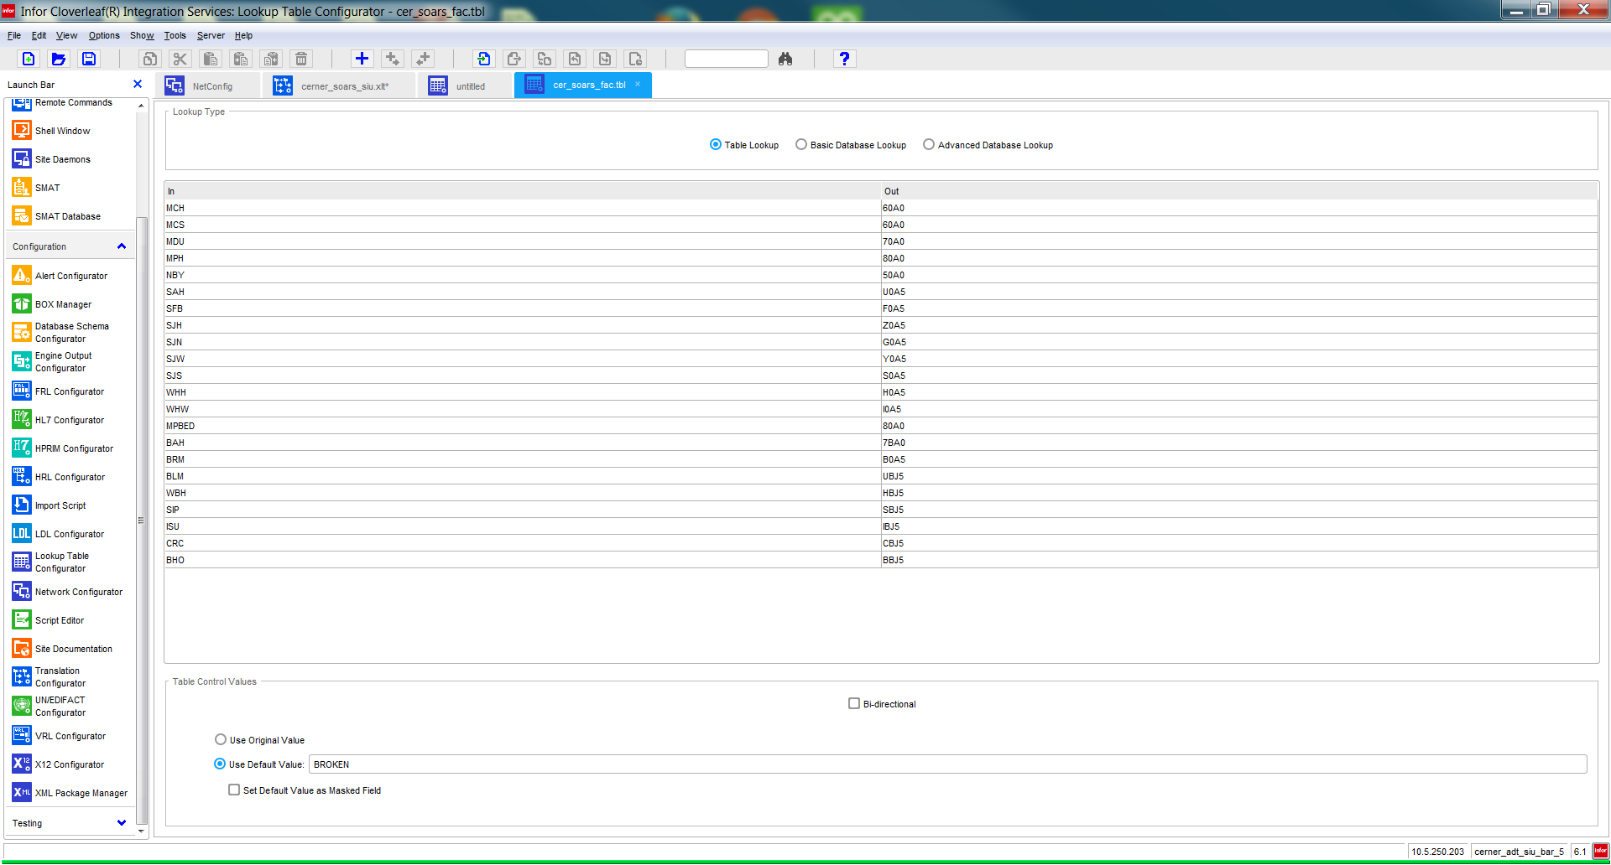

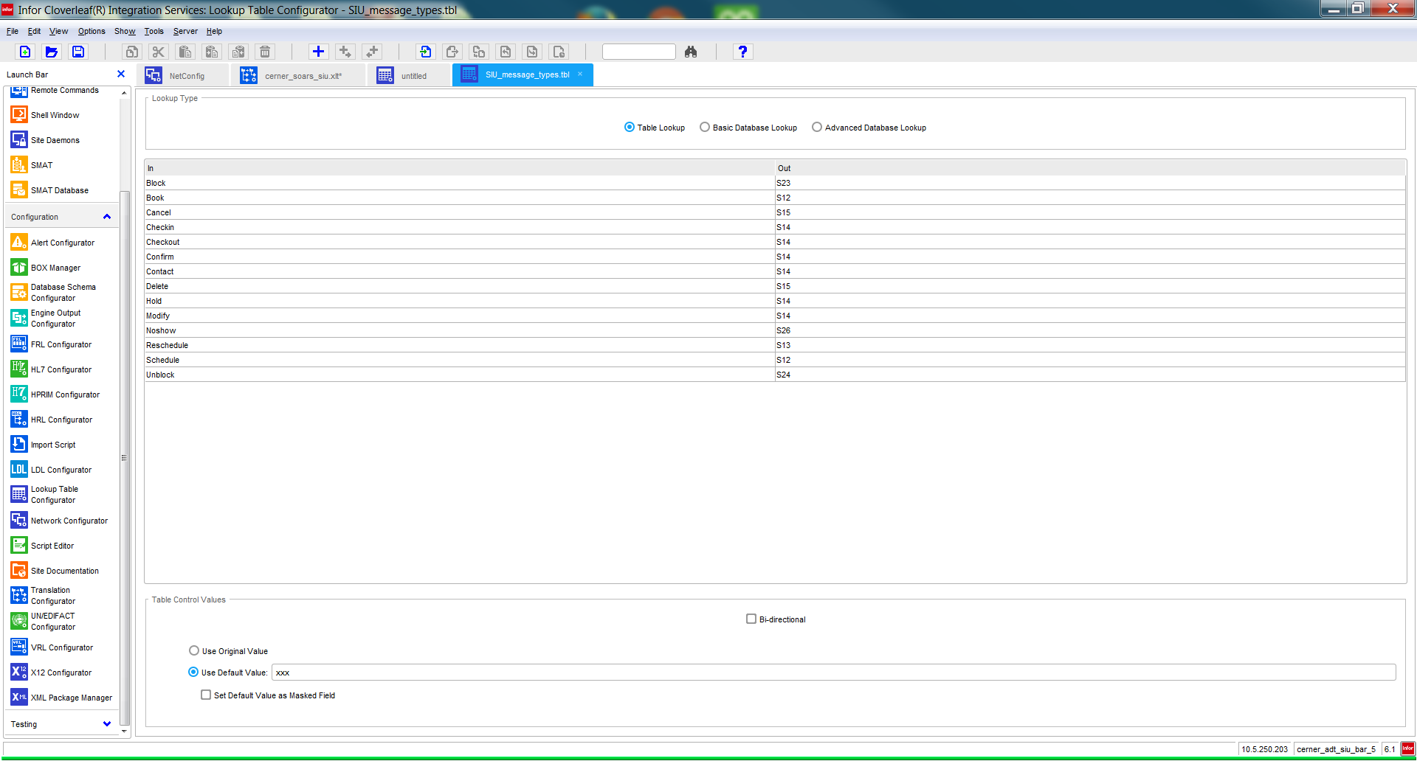

* End of document